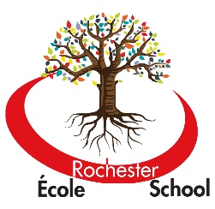
ÉCOLE ROCHESTER ELEMENTARY SCHOOL
411 Schoolhouse Street
Coquitlam B.C.
V3K 4Y7
(604) 939-4624
rochester@sd43.bc.ca

May 24, 2018

Dear Kindergarten Parents

Each year, parents are required to provide their child with a basic set of school supplies as requested by their classroom teacher. We know from experience that busy parents and crowded stores may not be all that desirable.

We can help!
If you would like to avoid the school supply shopping hassle, we can take care of this for you. Parents have the option of paying $40 to the school and we will purchase the necessary school supplies for your child.

If this offer interests you please attach a $40 post dated cheque for August 15, 2018 made out to Rochester Elementary. Please return to the office no later than Friday, June 15/18.

Please note that it is our approach in early primary at Rochester to pool these school supplies to promote shared responsibility, to avoid unnecessary comparisons between materials, and to build a “all for one, one for all” community. It is also far more cost effective to buy in bulk and ensure materials never run out.

Thank you for your support and co- operation!

Kind regards

Rochester Kindergarten Team

——————————————————————————————————————————

Student Name:________________________________________________________________

Parent Name: ________________________________________________________________

Please circle one: French Immersion English

I enclose $40 made payable to Rochester Elementary School, post dated for August 15/18.

